Me
Dania
Chantal
Malaika
Aspenne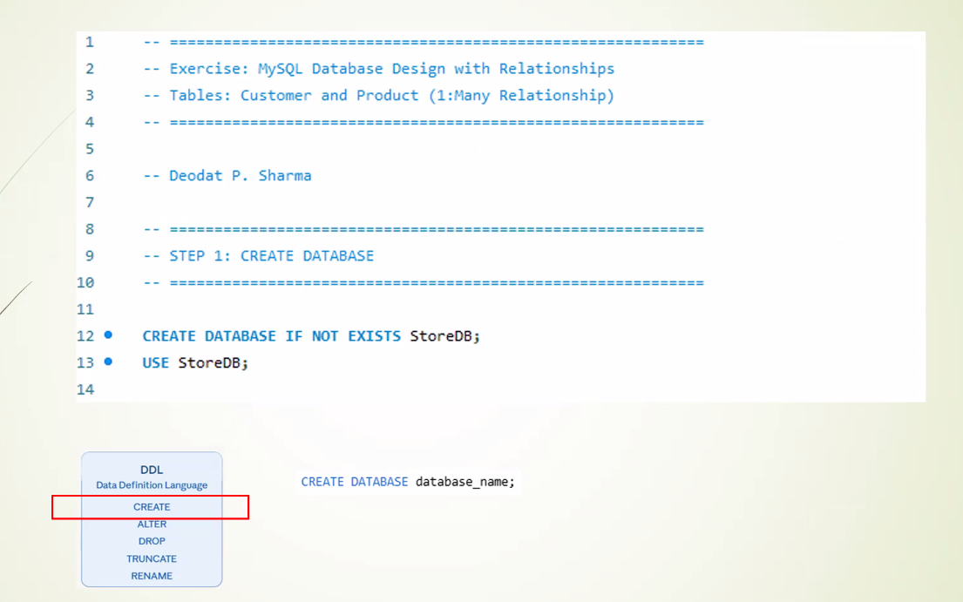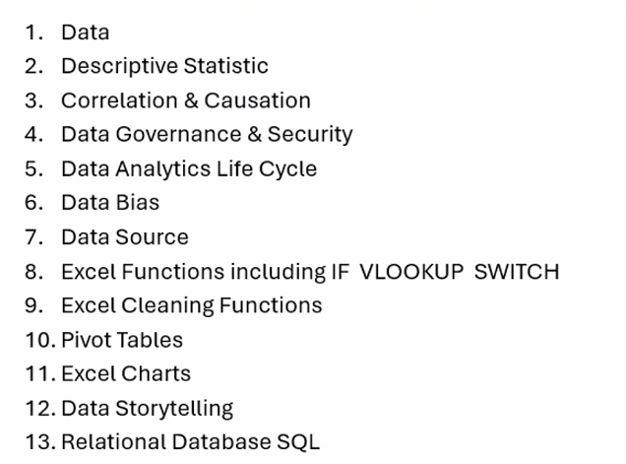
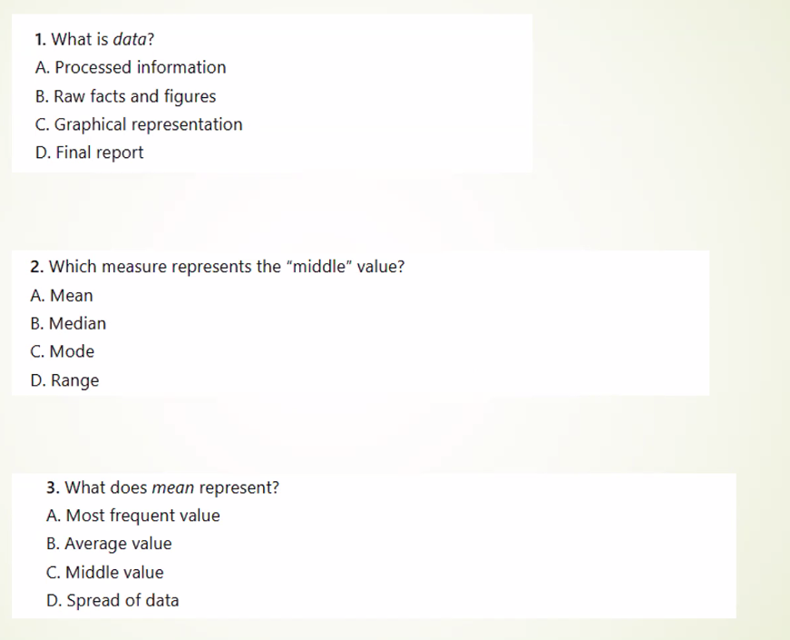B
B
B
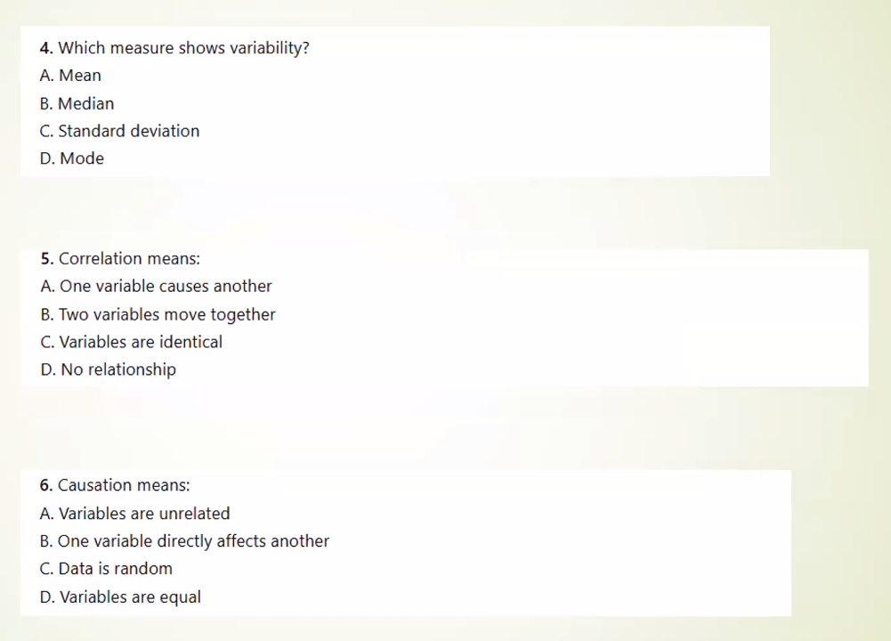
C
B
B
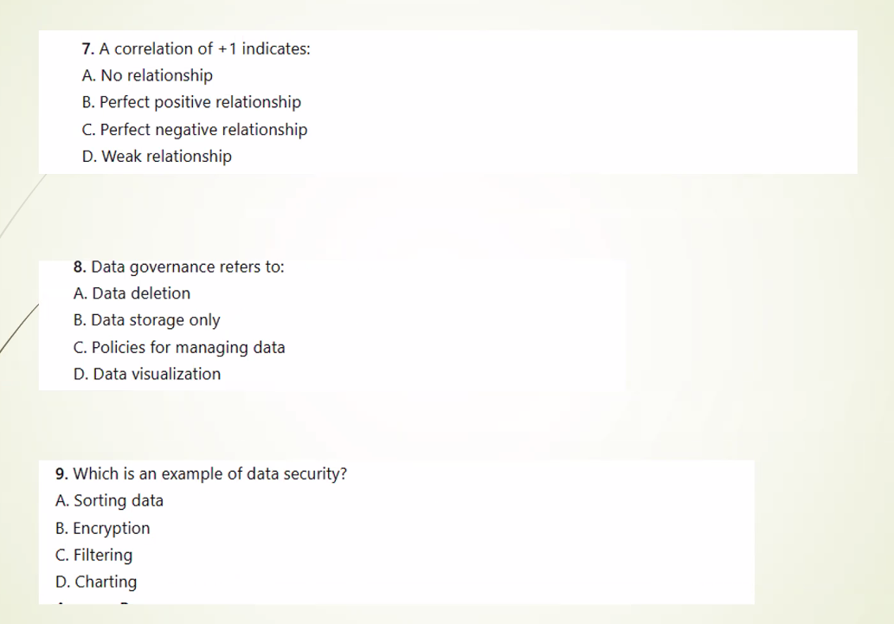
B
C
B
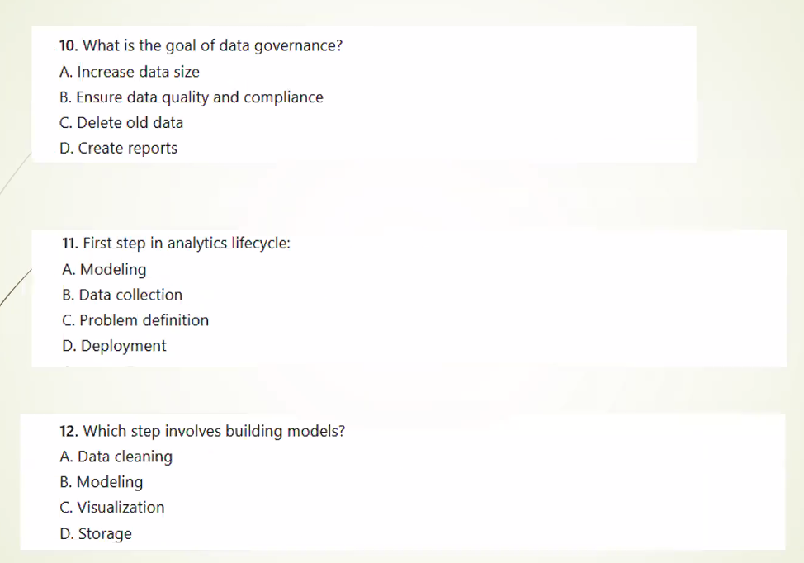
B
C
B
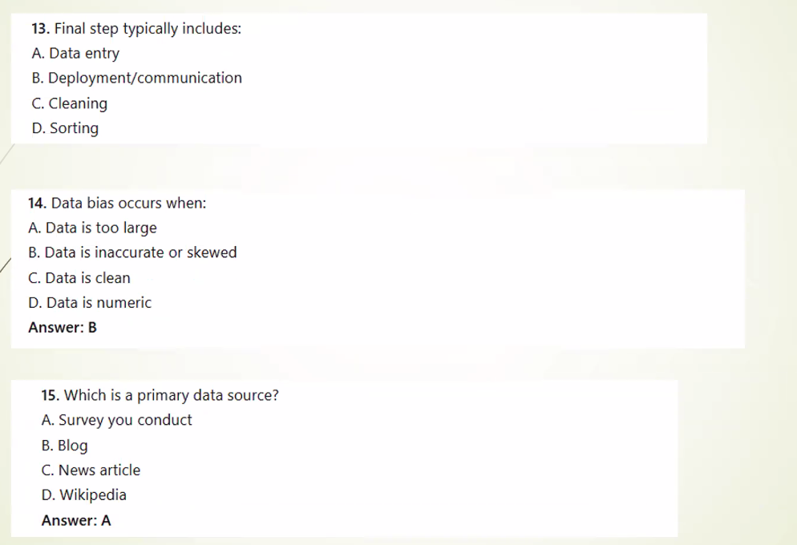
B
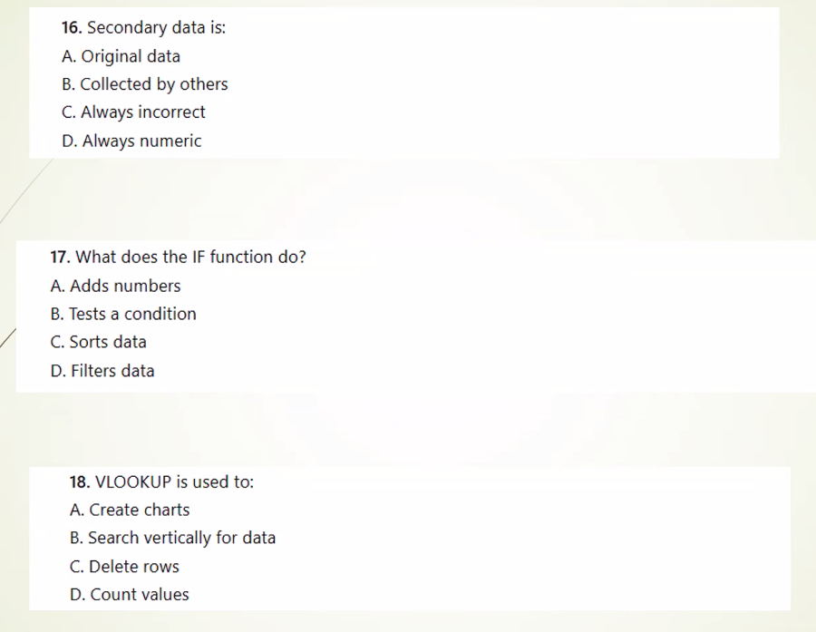
B
B
B

B
B
B

B
B
B

C
A
B
B
A
C
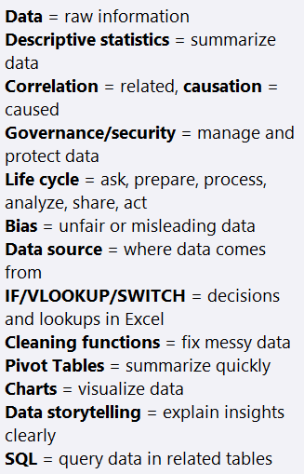
HYAAAAH

25 questions, 1 hour

WHY ARE SO MANY OF THESE ANSWERS B
I CANT TSAKE IT ANYMORE
I WANT TO DIE
I WISH I COULD DIE
PLEASE GOD KILL ME
PLEASE GOD KILL ME
PLEASE GOD KILL ME
PLEASE GOD KILL ME
PLEASE GOD KILL ME
PLEASE GOD KILL ME
PLEASE GOD KILL ME

